The Baby Boomers and their Toys!

Assignment: They say you can tell a lot about a generation based on the toys they grew up loving. Your assignment is to research one of the Baby Boomers’ favorite possessions! Due by the end of class today!

Research:

Research the Baby Boomers:
- Who were the Baby Boomers?
- What made this generation unique?
- Who is this generation today (select one celebrity
who is a former baby boomer)
Research the Toy:
- History: How was your toy/company invented?
- What made your toy so popular?
- How does your toy reflect the decade (for instance, the iPod reflects your decade’s technological advancements)
- How did your toy impact the Baby Boomers? Positives? Negatives?

Other things you’ll need to find:
- Large photo of your toy (MUST be a 1950s photo, look for ads)
- 1950s photo of the Baby Boomers in their natural surroundings (the suburbs)
- Photo of your Baby Boomer(s) today.

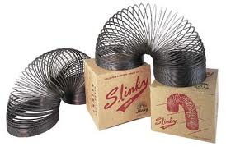
1950s Toys Selection:
- Barbie
- Easy Bake Oven
- Play-Doh
- Hula Hoops
- Frisbee
- Mr. Potato Head
- Tonka Trucks
- Pez Candy
- Matchbox Cars
- Slinky
- Yahtzee
- Erector Sets
- Betsy Wetsy

