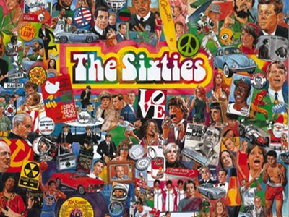
A Tour of the 1960s: A WebQuest of Life and Culture in the 1960's
Welcome to the ‘60s! During this WebQuest, you will be traveling back in time (via the Internet) to the world of the 1960s to explore the events and cultural trends that made this time period so unique. Follow the directions and get ready for an amazing journey!
Please complete the following questions on either a Google Doc or a MS Word doc and share/email it to me by the end of the period at maddenj@peabody.k12.ma.us
1. The first stop on your journey will be learn about the Fads and Fashion during the 1960s. Find answers to the following questions by using the sources below:
- Describe 3 of the fashion trends during this time period. Include an image with each description.
- What were hairstyles like (boy & girl)? Include an image with your description.
- List 3 popular toys from the 1960’s with images.
- List 3 fads from the 1960's with images.
Fashion of the 1960's websites:
http://www.fiftiesweb.com/fashion/hair-style.htm
http://www.fiftiesweb.com/fashion/sixties-fashion.htm
http://www.fiftiesweb.com/fashion/1960s-fashion-pants.htm
http://www.timewarptoys.com/timeline.htm
http://www.crazyfads.com/60s.htm
2. Now we will look at television and movies in the 1960s. Find the answers to the following questions by clicking on the hyperlinks below:
- List 5 popular T.V. shows from the 1960’s. Include images.
- Choose 4 movies from the 1960's and give a synopsis of the film. Include an image for each film.
- Explain how movies changed during this decade from previous decades and give 2 examples of movies that demonstrate that change
http://www.tvparty.com/fall1.html
https://www.oldies.com/collection/tv.cfm/tab_1960.html
http://sixties60s.com/1961movies.htm
Overview of the 60's

3. Another area that changed dramatically during the 1960’s is art and culture. Use the links below to find out about the changes.
- List two cultural changes that occurred in literature written during the 1960s.
- What influenced American art during the 1960s?
- Describe the artist Andy Warhol and his cultural revolution of “pop art”.
http://sixties60s.com/1960books.htm
http://www.artsconnected.org/collection/118487/art-in-the-1960s?print=true
Artist Profile: Andy Warhol
Overview of the 60's
4. The 1960s were a time of great change in the United States – one of the biggest changes was the emergence of “hippies” and a generation of youth who rebelled against traditional culture. Follow the link to learn a little more about this counterculture movement
- Explain the “hippie” movement. Who were they, what did they do, where were they located, and why were they a part of a counterculture movement?
http://www.ehow.com/about_5375320_history-hippie-movement.html
http://blastfrompast.wikispaces.com/Hippie+Culture
5. Finally, major national and international events impacted the 1960’s in many ways. Examine some of the major news events during this decade and answer the questions below.
List the presidents of the United States during this decade.
List and explain three historic events that caused massive changes in society during the 1960s.
**http://www.thepeoplehistory.com/1960s.html**
**http://www.auroraontheweb.com/east66/1966/66econ.html**
**http://www.wgeneration.com/1960.html**
**http://www2.scholastic.com/browse/article.jsp?id=4993**
Overview of the 60's

You've come to the end of your trip around the 1960s!

