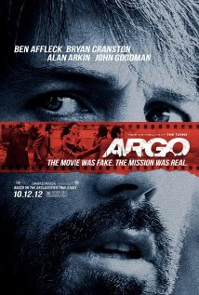
ARGO

- Why did the students in the Iranian Revolution take over the US
embassy in Tehran?

- Name three different rescue options the CIA proposed to bring home the 6 Americans that had escaped.

- Describe Tony Mendez’s plot of “Argo”.

- What do the revolutionaries learn when they start to reassemble shredded documents?

- Why do you think the US waited until 1997 (18 years!) to release the details of Tony Mendez’s rescue operation of the 6 hostages?

- Given the fact that the audience will take away from this film a vivid impression of the 1979-1981 Iran hostage crisis, do you think that, on the whole, this film improves the viewer's understanding of the important historical events as they actually occurred? Justify your conclusion.

