Name _______________________________________________ Date______________

Battle of Favored Sons

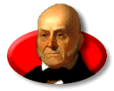
Candidate: _________________________________________

Party: _____________________________________________

Home State: ________________________________________

Info: ______________________________________________

________________________________________________________________________

________________________________________________________________________

________________________________________________________________________

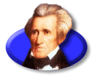
Candidate: _________________________________________

Party: _____________________________________________

Home State: ________________________________________

Info: ______________________________________________

________________________________________________________________________

________________________________________________________________________

________________________________________________________________________

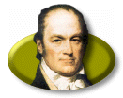
Candidate: _________________________________________

Party: _____________________________________________

Home State: ________________________________________

Info: ______________________________________________

________________________________________________________________________

________________________________________________________________________

________________________________________________________________________
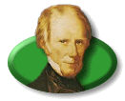
Candidate: _________________________________________

Party: _____________________________________________

Home State: ________________________________________

Info: ______________________________________________

________________________________________________________________________

________________________________________________________________________

________________________________________________________________________

Results of the Election of 1824:
________________________________________________________________________________________________________________________________________________________________________________________________________________________________________________________________________________________________________________________________________________________________________
Corrupt Baragin:
________________________________________________________________________________________________________________________________________________________________________________________________________________________________________________________________________________________________________________________________________________________________________
____________________________ Presidency:
________________________________________________________________________________________________________________________________________________
Election of 1828:
________________________________________________________________________________________________________________________________________________________________________________________________________________________________________________________________________________________________________________________________________________________________________

