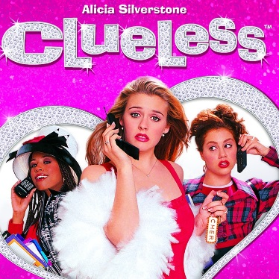
Clueless - Quiz Grade!
Clueless is a movie known for its slang. Describe what scenes in the movie the
following slang phrases are used:
“As if!” (an expression of utter disgust)

“Audi” (variation of “we’re outta here”)

“Betty” (an attractive female)

“Baldwin” (a good looking guy)

“Barney” (a ordinary, unremarkable guy)

“Buggin” (freaking out/overreacting)

“Check it!” (means “Listen up!”)

“Loadie” (a drug user)

“Monet” (someone who is good looking from a distance but a mess up close)

“Jeepin” (fooling around in the backseat of a car)

“Solid” (having a relationship with no fighting ever)

“Tscha!” (“Surely you jest!”

“Whatever!” (Universal passive-aggressive response to any question or demand)

Provide 2 scenes that showcase 90’s feminism:

