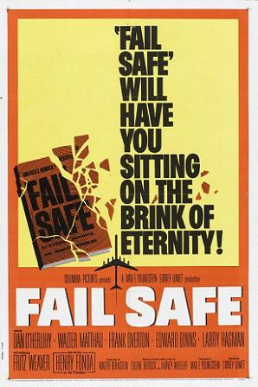
Fail-Safe
Test grade – due when the film is complete

- List three defects in the fail-safe system shown in this film.

- In the film, why do the American bombers continue to fly past their fail-safe points?

- Why didn't the pilot listen to the President, his superior officers, or even his son?

- In the movie, what orders are given to the Air Force fighter planes? What happens to them?

- Should we eliminate nuclear weapons if we cannot be sure there will be no accidental detonations?

- What are your impressions of Professor Groeteschele? Do you agree or disagree with him? Is he a Cold War relic or do voices such as his have relevance today?

- Was it a wise policy for the pilots to be ordered to ignore verbal changes of their orders? If not, what other alternative was there?

- Do terrorists present a greater nuclear threat than the risk of a nuclear war caused by accident? If so, do the issues raised in the movie "Fail-Safe" still matter?

