Name: _______________________________________________ Date:________ Class:___________

Gaslight (1944)
Test grade
- Provide three examples of scenes that film noir characteristics are found in. Describe both the scene and the characteristic. (6 pts.)

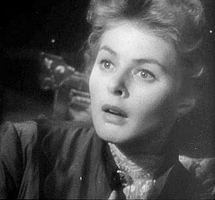
Example 1:

Example 2:

Example 3:

- After WWII, Americans wanted to watch actors in actual locations. Where does the majority of the movie take place? (2 pts). ___________________________

- What does Paula discover in an old music book? How does Gregory react to Paula’s find? (2 pts.)

________________________________________________________________________________________________________________________________________________________________________________________________________________________________________________________________________________________________________________________________________________

- What does Paula lose at the Tower of London? (1 pt) ________________________________

- How does the maid, played by Angela Lansbury, always treat Paula? (2 pts) ______________________
____________________________________________________________________________________
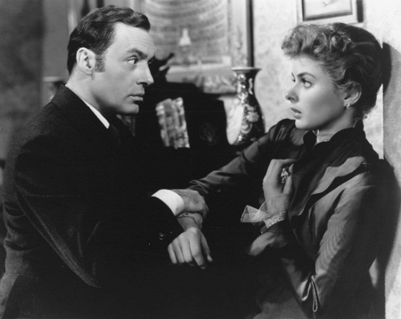

- How is Gregory’s treatment of Paula different from the beginning of the movie to the middle of the movie? (2 pts)
________________________________________________________________________________________________________________________________________________________________________________________________________________________________________________________________________________________________________________________________________________

- Why does Paula think she is going mad? (2 pts)
________________________________________________________________________________________________________________________________________________________________________________________________________________________________________________________________________________________________________________________________________________

- Who really is Gregory Anton? (1 pt) ______________________________________________________
- How does Paula get revenge at the end of the movie? (2 pts)



