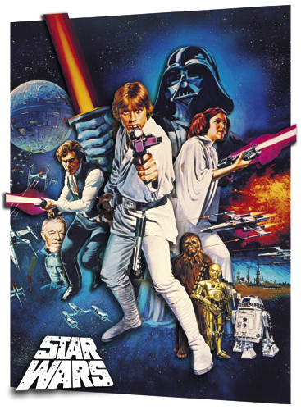
Name: _______________________________
Star Wars IV:
A New Hope

- Explain how this film illustrates the real life battle between American Democracy and Soviet Communism.

- There are a lot of hero-types in this film, but who do you think is the Underdog? Why?

- Select three scenes that reflect “All American” values.
______________________________________________________________________________
______________________________________________________________________________
______________________________________________________________________________

- Who is the Villain? Describe how he fits our perceptions of what a Soviet acts like, looks like, etc.

- Technologically speaking…why is this movie such a major breakthrough?

6. Comparing Rocky and Star Wars which is the better all American hero?

