Name________________________________________________________________________ Date_________
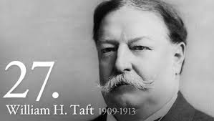
William Howard Taft’s Presidency
With TR’s endorsement Taft easily defeats William Jennings Bryan to become the 27th President. Taft considered himself a progressive, in part from his belief in an expansive use of the rule of law, as the prevailing device that should be actively used by judges and others in authority to solve society's, and even the world's, problems. But his devotion to the law also often made Taft a slave to precedent and less adroit in politics than Roosevelt; he therefore lacked the flexibility, creativity and personal magnetism of his mentor, not to mention the publicity devices, the dedicated supporters, and the broad base of public support that made Roosevelt so formidable.
Foreign Policy
Dollar Diplomacy: ___________________________________________________________________________________
____________________________________________________________________________________________________________________________________________________________________________________________________
____________________________________________________________________________________________________________________________________________________________________________________________________
Domestic Policy
Payne-Aldrich Tariff Act: ______________________________________________________________________________
____________________________________________________________________________________________________________________________________________________________________________________________________
____________________________________________________________________________________________________________________________________________________________________________________________________
Ballinger-Pinchot Controversy: _________________________________________________________________________
____________________________________________________________________________________________________________________________________________________________________________________________________
____________________________________________________________________________________________________________________________________________________________________________________________________
Trust Busting: ______________________________________________________________________________________
____________________________________________________________________________________________________________________________________________________________________________________________________
____________________________________________________________________________________________________________________________________________________________________________________________________

16th Amendment: ___________________________________________________________________________________
____________________________________________________________________________________________________________________________________________________________________________________________________
____________________________________________________________________________________________________________________________________________________________________________________________________
Election of 1912:
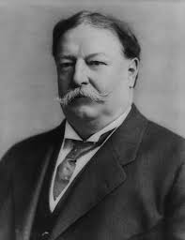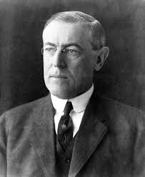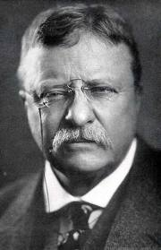
Candidate:__________________________________________________________________________________
Party:______________________________________________________________________________________
__________________________________________________________________________________________________
____________________________________________________________________________________________________________________________________________________________________________________________________
____________________________________________________________________________________________________________________________________________________________________________________________________
Taft’s Legacy: ______________________________________________________________________________________
____________________________________________________________________________________________________________________________________________________________________________________________________
____________________________________________________________________________________________________________________________________________________________________________________________________

