Name__________________________________________________________________ Date_______________
Theodore Roosevelt’s Presidency
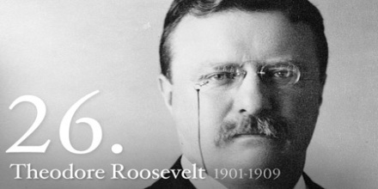
After William McKinley’s assassination in Buffalo, Theodore Roosevelt was sworn in as the 26th President. His exuberant personality would help guide the country through the Progressive movement and help it emerge as a world power.
Directions: Detail TR’s success in Domestic and Foreign policy
Foreign Policy : TR believed the US was in competition with the other nations of the world and only the fittest would survive.
Open Door Policy: ___________________________________________________________________________________
____________________________________________________________________________________________________________________________________________________________________________________________________
____________________________________________________________________________________________________________________________________________________________________________________________________
Roosevelt Corollary: _________________________________________________________________________________
____________________________________________________________________________________________________________________________________________________________________________________________________
____________________________________________________________________________________________________________________________________________________________________________________________________
Domestic Policy: TR firmly believed that government should actively balance the needs of competing groups in American Society.
Square Deal: _______________________________________________________________________________________
____________________________________________________________________________________________________________________________________________________________________________________________________
____________________________________________________________________________________________________________________________________________________________________________________________________
Business
Trust-busting: ______________________________________________________________________________________
____________________________________________________________________________________________________________________________________________________________________________________________________
____________________________________________________________________________________________________________________________________________________________________________________________________
Bureau Corporation: _________________________________________________________________________________
____________________________________________________________________________________________________________________________________________________________________________________________________
____________________________________________________________________________________________________________________________________________________________________________________________________
Hepburn Act: _______________________________________________________________________________________
______________________________________________________________________________________________________________________________________________________________________________________________________________________________________________________________________________________________________
__________________________________________________________________________________________________
Unions: ___________________________________________________________________________________________
____________________________________________________________________________________________________________________________________________________________________________________________________
____________________________________________________________________________________________________________________________________________________________________________________________________
Consumer
Meat Inspection Act: _________________________________________________________________________________
____________________________________________________________________________________________________________________________________________________________________________________________________
____________________________________________________________________________________________________________________________________________________________________________________________________
Pure Food and Drug Act: ______________________________________________________________________________
____________________________________________________________________________________________________________________________________________________________________________________________________
____________________________________________________________________________________________________________________________________________________________________________________________________
Environment
Conservation: ______________________________________________________________________________________
____________________________________________________________________________________________________________________________________________________________________________________________________
____________________________________________________________________________________________________________________________________________________________________________________________________

